CODING ASSESSMENT – 21-07-2025

USE burger_bash;
TABLES
1.burger_names
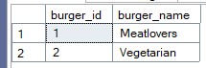
2.burger_runner
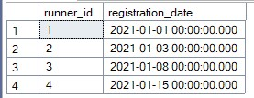
3.customer_orders
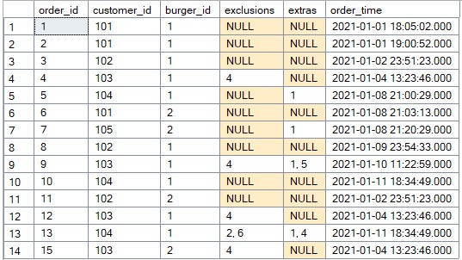
4.burger_runner_orders
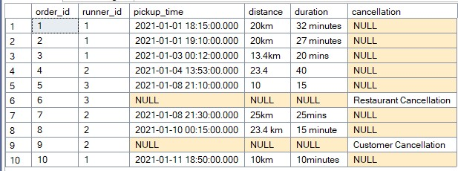

-- 1. Total Revenue Generated per Runner

SELECT
r.runner_id,
SUM(CASE WHEN bro.distance LIKE '%km%'
THEN CAST(REPLACE(bro.distance, 'km', '') AS FLOAT) * 1.5 -- Assume €1.5/km
ELSE CAST(bro.distance AS FLOAT) * 1.5 END) AS revenue
FROM burger_runner_orders bro
JOIN burger_runner r ON bro.runner_id = r.runner_id
WHERE bro.cancellation IS NULL
GROUP BY r.runner_id;
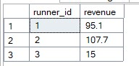
-- 2. Average Delivery Time per Runner (Minutes)

SELECT
runner_id,
AVG(CAST(SUBSTRING(duration, 1, PATINDEX('%[^0-9]%', duration + 'x') - 1) AS INT)) AS avg_delivery_time_minutes
FROM burger_runner_orders
WHERE cancellation IS NULL AND duration IS NOT NULL
GROUP BY runner_id;
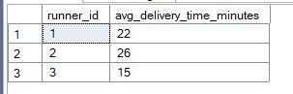
-- 3. Most Popular Burger with Exclusions/Extras

SELECT TOP 1
b.burger_name,
COUNT(*) AS customized_orders_count
FROM customer_orders co
JOIN burger_names b ON co.burger_id = b.burger_id
WHERE co.exclusions IS NOT NULL OR co.extras IS NOT NULL
GROUP BY b.burger_name
ORDER BY customized_orders_count DESC;
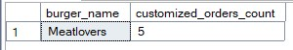
--4. Percentage of Cancelled Orders by Cause

SELECT
cancellation,
COUNT(*) AS cancellation_count,
ROUND(COUNT(*) * 100.0 / (SELECT COUNT(*) FROM burger_runner_orders), 2) AS percentage
FROM burger_runner_orders
WHERE cancellation IS NOT NULL
GROUP BY cancellation;
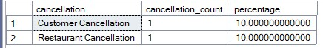
--5. Customer Order Frequency Analysis

SELECT
customer_id,
COUNT(*) AS order_count,
DENSE_RANK() OVER (ORDER BY COUNT(*) DESC) AS customer_rank
FROM customer_orders
GROUP BY customer_id;
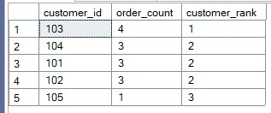

--6. Runner Efficiency by Order Volume & Distance

SELECT
bro.runner_id,
COUNT(bro.order_id) AS completed_orders,
SUM(CAST(REPLACE(REPLACE(bro.distance, 'km', ''), ' ', '') AS FLOAT)) AS total_distance_km,
SUM(CAST(REPLACE(REPLACE(bro.distance, 'km', ''), ' ', '') AS FLOAT)) / COUNT(bro.order_id) AS avg_distance_per_order
FROM burger_runner_orders bro
WHERE bro.cancellation IS NULL
GROUP BY bro.runner_id
ORDER BY completed_orders DESC;
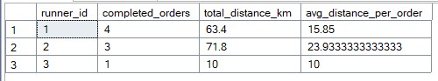
--7. Minimum Delivery Time (Fastest Order)

SELECT
MIN(CAST(SUBSTRING(duration, 1, PATINDEX('%[^0-9]%', duration + 'x') - 1) AS INT)) AS min_delivery_time_minutes
FROM burger_runner_orders
WHERE cancellation IS NULL AND duration IS NOT NULL;
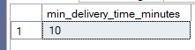
--8. Maximum Distance Covered for Successful Deliveries

SELECT
MAX(CAST(REPLACE(REPLACE(distance, 'km', ''), ' ', '') AS FLOAT)) AS max_distance_km
FROM burger_runner_orders
WHERE cancellation IS NULL AND distance IS NOT NULL;
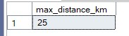
--9. Runner with Minimum Deliveries (WHERE + Aggregate)

SELECT TOP 1
runner_id,
COUNT(order_id) AS deliveries
FROM burger_runner_orders
WHERE cancellation IS NULL
GROUP BY runner_id
ORDER BY deliveries ASC;

SELECT * FROM customer_orders;

